**To: Paige Altemare, Daniel Sederholm, Neal Krentz**

**From: Daniel Gil**

**CC: Dr. McBrain**

**Re: Re: Heat Exchanger Networks**

Dr. McBrain, Director of R&D of Gardner Edwards Chemical Co., has assigned us to the task of design a new separation train using four gas membrane modules. In order to achieve the optimal process that yields the maximum production, we will need to determine the how the gas membrane module reacts to changes in stage cuts and retentate pressure.

This report describes in detail how we will be able to:

1. Determine the permeances for oxygen and nitrogen, and therefore calculate the permeability ratio of oxygen to nitrogen for the laboratory membrane module.
2. Determine the effects of stage cut and retentate pressure on the permeate and retentate concentrations and permeate flow rate.
3. Determine under what conditions the perfect mixing model is valid. Check the assumption that the bore-side (permeate) pressure drop is negligible to confirm that the perfect mixing is a valid assumption.

In order to fulfill this, the following team has been assembled to complete the tasks.

* Dan Gil is the foreman for this lab. His main responsibility is to coordinate the team to run the experiments safely and effectively.
* Paige Altemare and Daniel Sederholm are the hardware operators for this lab. They are responsible for using the valves in the experimental apparatus to control the pressures and flow rates of the gases.
* Neal Krentz is responsible for analysis of the data. He will use the computer to interpret data and help the foreman direct the hardware operators.

**Safety**

General lab safety protocols should be practiced during this session.

* All workers should wear proper attire and equipment. That means: long pants, closed-toe shoes, lab coats, and safety glasses. Contact lenses are not allowed in the lab.
* Food or drink is not allowed in the lab.
* Everyone must be attentive and alert at all times. Distractions like texting or phone calls are not allowed.
* The fire extinguisher can be found by the main door and by the shop.
* The fire blanket can be found by the main door.
* The safety shower is in the hall just outside the lab.
* There are two fire call boxes in the main hallway, by the exit doors.

Pure nitrogen gas, pure oxygen gas, and air will be used in this experiment. Despite the fact that these gases are commonly found in the atmosphere, they still pose several risks.

* Nitrogen gas can cause asphyxiation. Do not breathe with mouth/nose close to the gas outlets. Check for leaks in the experimental apparatus.
* Oxygen gas is an oxidizing agent. It is a fire hazard since it can make other chemicals very flammable.
* All tanks are under high pressure. Each tank must be checked to make sure they are properly secured.
* The valves and the regulators on gas tanks are the weakest parts. Be careful not to hit them with something.
* Shut off the tanks in an emergency, if possible.

Important Phone Numbers

Campus Security (216)368-3333

Safety Services (216)369-2907

Dr. Wainright (216)368-5382

Craig Virnelson (216)368-1689, (440)842-6892

University Health Services (216)368-2450

**Apparatus**

Gas Tanks

There are three gas tanks: one of each for oxygen, nitrogen, and air. The valve on each of the tanks can be used to control the inlet pressure, which is displayed on the sindicator next to the valve.

Nitrogen Oxygen Air

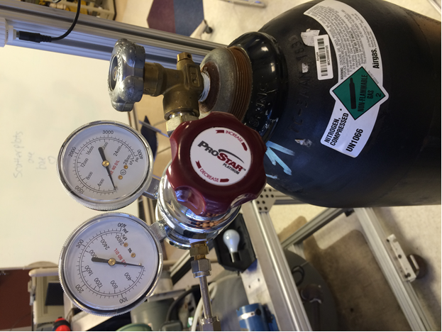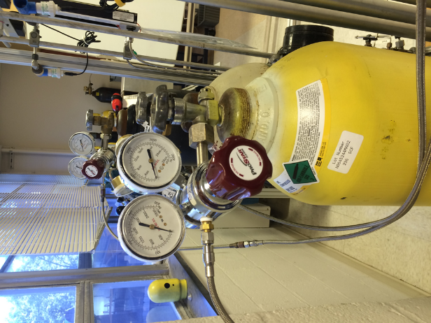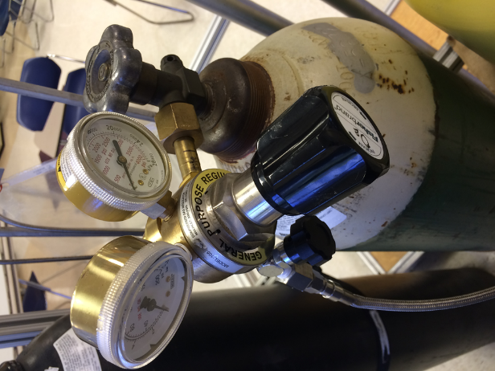

The membrane module used in this experiment has two counter-current and two co-current columns. The four columns make up the 1 PRISM gas membrane module. The retentate flows through the columns in series, while the permeate flows out of the columns in parallel.

Membrane Columns (PRISM)

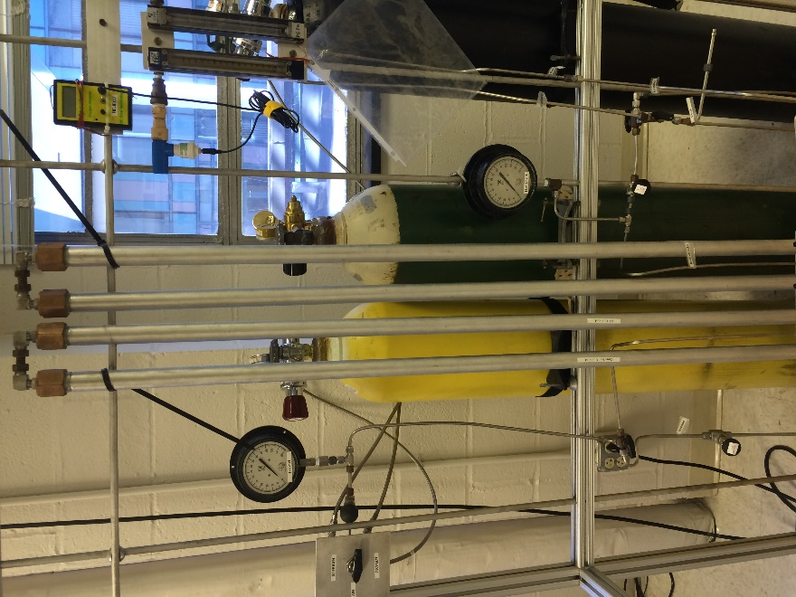

Control Valve and Pressure Gauge for Inlet Gas

This is the needle valve used to control which gas is flowing into the system. The short pointy side indicates the setting of the valve. For instance, in the picture below, the current setting is to let air into the system. The pressure sensor is seen on the right of the control valve.

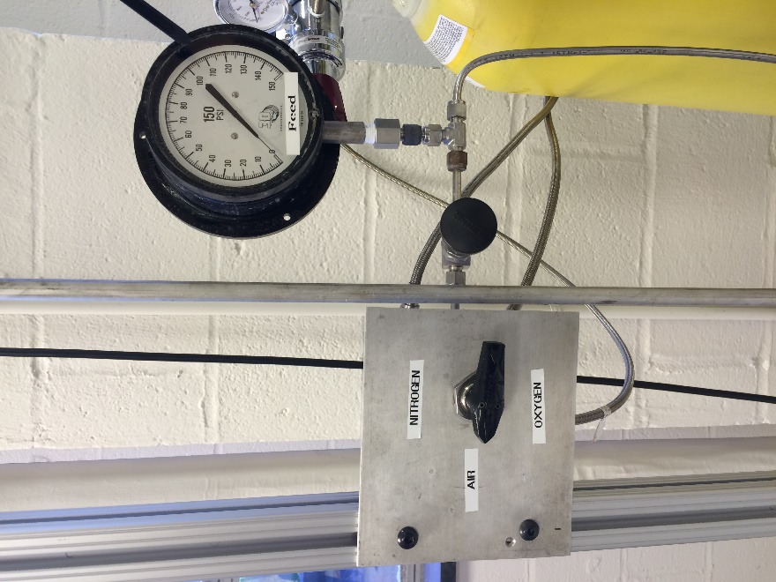

Concentration Sensors and Rotameters

There are sensors that detect the concentration of oxygen in the retentate and the permeate streams. On top left is the retentate (reject) concentration sensor and on the top right is the permeate concentration sensor. They will both be calibrated in the beginning of the experiment. On the bottom left is the flow meter for the retentate and on the bottom right is the flow meter for the permeate. Calibration curves for the flow meters are provided.

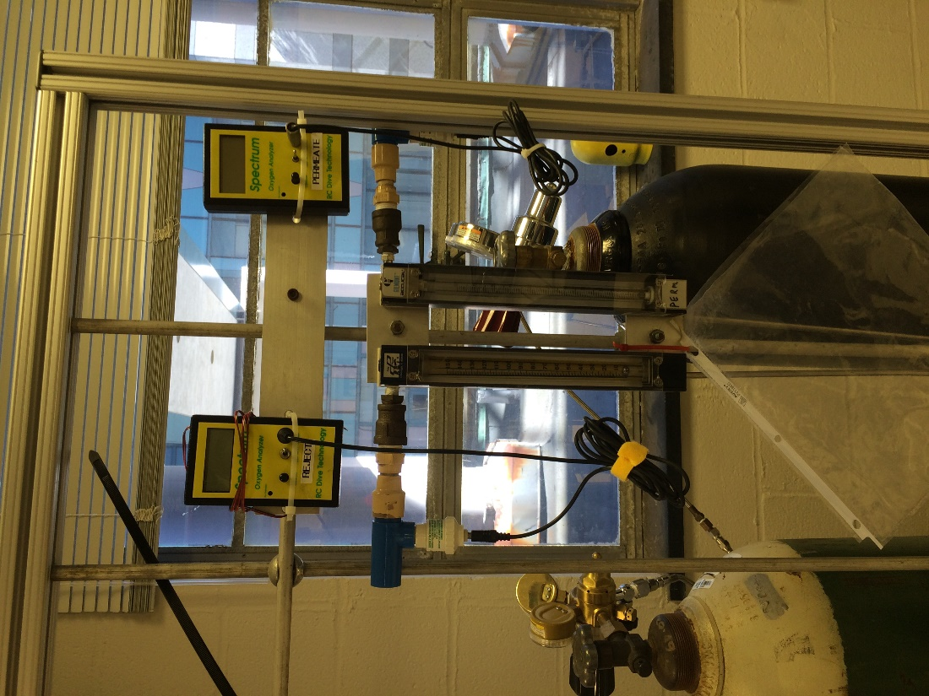

Retentate (Reject) Pressure Gauge

The retentate pressure can also be measured with this pressure gauge.

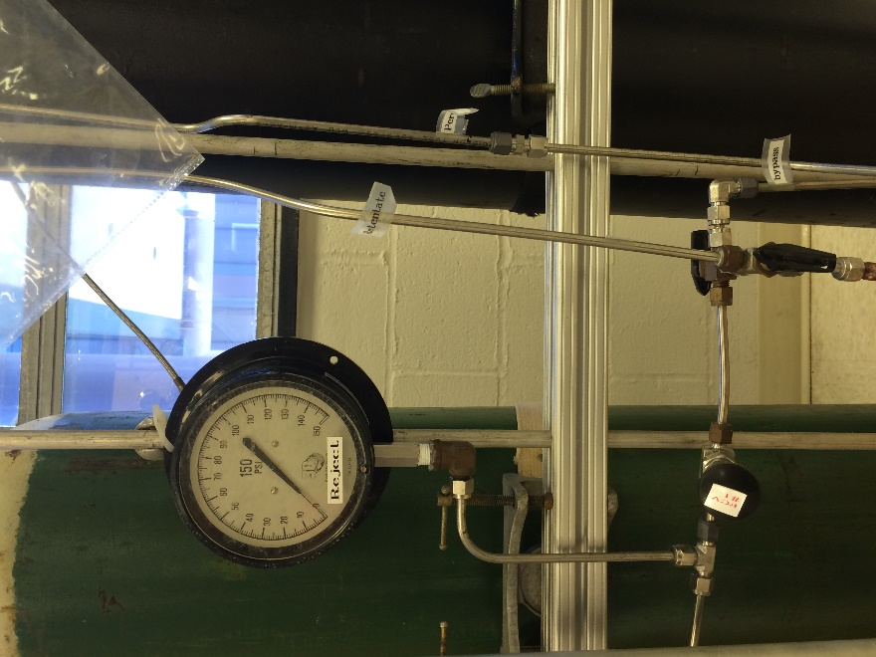

Various Needle Valves

There are numerous needle valves that can direct the flow of the inlet gases. Valve A has positions Left, Up, and Right (see diagram). Position Left makes the inlet gas bypass all four columns. Position Up stops the inlet flow. Position Right sends the inlet gas to the columns. Valves B1 through B4 are used to channel the flow rate of permeate from each column. They have Up position (stop flow) and Down position (allow flow). Valve C allows the bypass stream from the inlet gas to continue to the rotameter and the concentration sensors. Valve D allows the permeate stream from the columns to continue to the rotameter and the concentration sensors, or to vent the permeate gas. Valve E directs the flow of the rententate stream to the rotameter and the concentration sensors.

The circular knobs are used to control the flow rates.

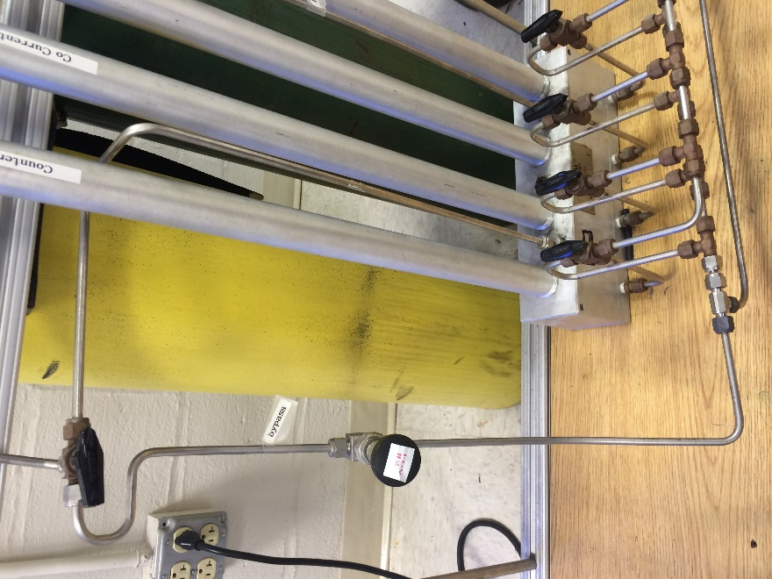 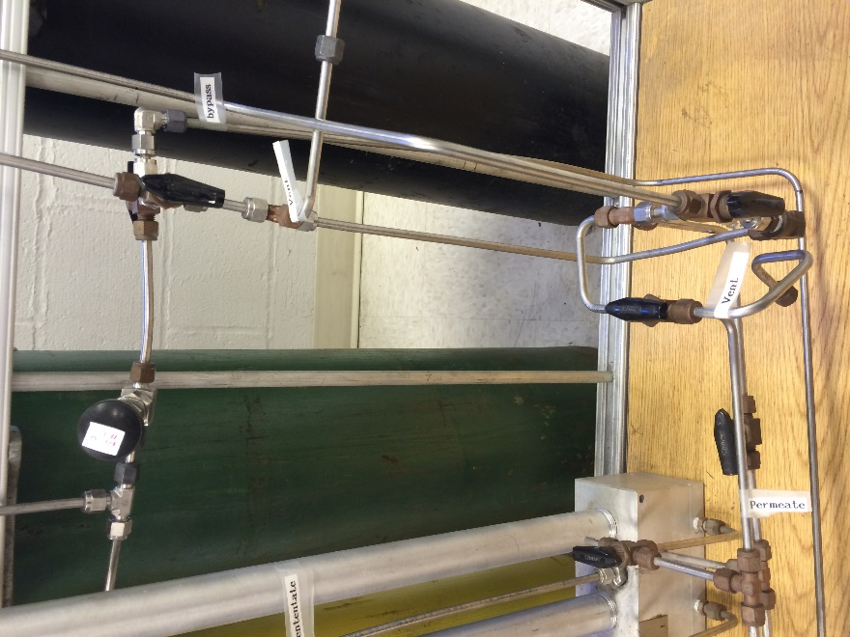

**K2**

**K1**

**E**

**D**

**C**

**B1-4**

**A**

**Methods**

**Calibration**

1. Close K1.
2. Set the inlet gas setting to OFF.
3. Set the valves so that the feed gas bypasses the membrane module..
4. Set the pressure of air to 15 psig.
5. Slowly open K1 valve to set the flow rate to 10, as indicated by the rotameter for reject. The sensors should read 20.9% within 5 minutes.
6. Do the same with oxygen; the concentration sensors should read 100% within 5 minutes.
7. If the reading did not stabilize at 100%, adjust the sensor to 100% and repeat step 1.
8. Close all valves, and knobs, close all tanks.

**Determine Permeances and Permeability Ratio**

O2/N2 Permeance

1. Close K1.
2. Set the inlet gas setting to OFF.
3. Set the valves so that the feed gas is directed into the columns.
4. Set the pressure of oxygen to 15 psig.
5. Slowly open K1 valve to set the flow rate to 10, as indicated by the rotameter for reject.
6. Once the system reaches steady state, record the Feed Pressure, Retentate Pressure, Retentate Flow Rate, Permeate Flow Rate.
7. For oxygen pressure of 20, 25, 30, and 35 psig, repeat steps 3 through 6.
8. Do steps 1 through 7 for nitrogen with pressure of 65, 75, 85, 95, and 100 psig.

**Determine Effect of Stage Cut and Retentate Pressure**

Varying Stage Cut

1. Following the conditions described in the Excel File, “Vary Stage Cut”, measure the outlet concentrations.

Varying Feed Pressures

1. Following the conditions described in the Excel File, “Vary F Pressure”, measure the outlet concentrations.